**DESIGN SPECIFICATIONS DOCUMENT**

An automated system for microscope-based, real-time image capture of cancer cells & drug treatment evaluation

Prepared for:

CytoImage DX

By:

Angeline Alfred

Ashten Bontrager

Huanle Zhou

Timothy Koba

Version 1.1.1.

Prototype draft

Issued:

March 5th, 2019

TABLE OF CONTENTS

**1** **INTRODUCTION**

1.1 Purpose of The Design Specifications Document………………………………….. 3

1.2 Problem Overview………………………………………………………………….. 3

1.3 Proposed Solution………………………………………………………………….. 3

1.4 Deliverables………………………………………………………………………....4

**2** **DESIGN REQUIREMENTS**

2.1 Provided Hardware………………………………………………………………….5

2.2 Software Specs & Capabilities…………………………………………….………..5

2.3 Documentation Requirements……………………………………………………… 5

**3** **SYSTEM ARCHITECTURE DIAGRAMS**

3.1 Overall System Data Flow Chart.………………………………………………….6

**4****WORKFLOW**

4.1 Team Member Deliverable Assignments…..……………..…………………….….7

4.2 Gantt Chart…………………………..………………………………………….….8

**5****DESIGN SPECIFICATIONS APPROVAL**………………………………………………..9

# 

# Introduction

## Purpose of the Design Specifications Document

The purpose of this document is to convey our understanding of what the product must accomplish. It will help identify and clarify misunderstandings concerning the product requirements between the sponsor, CytoImage DX, and the development team. It will also provide the sponsor with insight to our work breakdown.

## Problem Overview

Hematologic malignancies, such as lymphoma, leukemia or myeloma, are the fifth most common type of cancer and fourth most common form of cancer-related death. In the U.S. alone, there are more than 1 million people who suffer from hematologic malignancies, with approximately 150,000 more patients diagnosed every year. Targeted drugs are a driving focus of drug development, but the majority of patients eventually develop resistance, even to these new drugs. As a result, many leukemia patients eventually succumb to their diseases due to resistance to both conventional chemotherapies and newer targeted agents.

In response to this issue, the Oregon Health and Science University along with members of the Knight Cancer Center developed the CytoScreen process to help identify novel drugs that produce complete kill of drug-resistant cancer cells. The CytoScreen is a miniaturized single-cell assay that is performed in multi-well chambers on a fluorescent microscope-imaging platform. It is an ultra-sensitive system that enables imaging of patient blood samples with single-cell granularity.

CytoScreening is a process requiring time-intensive scanning and acquisition of large numbers of images. Because the drug-resistant cells that underlie cancer recurrence are often present at low frequencies (<0.1%) in an individual patient, the majority of the acquired images are not used.

## Proposed Solution

Integrating and/or generating microscope-controlling, image processing, and decision-making software that will automate and conduct real-time selective image acquisition of the blood sample images using the microscope-computer-camera setup. Only z-stacked blood sample images containing cancer cells will be acquired under different monochromatic excitation, and light filtering (channels). Portions of the sample without cancerous cells will only be captured as single images under the DIC and cancer cell detecting channels. These images will be used by CytoImage DX to evaluate the effectiveness of a particular drug treatment.

The software will:

* Automatically scan through blood samples on a microscope slide.
* Determine a region of interest (ROI) by measuring cellular fluorescent light intensity in an image.
* Cells are considered to be cancerous only if cellular fluorescent intensity is higher than the user-established threshold.
* If cancer cells are detected, images of the same region will be obtained through the remaining five light filters (channels) the Zeiss AxioImager M2 hosts at various image depths.
* The resulting system will be user-friendly, with a graphical user interface and significantly increase the selective image acquisition speed.

## deliverables

|  |  |  |  |
| --- | --- | --- | --- |
|  | **Project Deliverables** | **Owner** | **Status** |
| 1 | Design Specifications & Documentation | All | In progress |
| 2 | Gantt Chart | Ashten | Complete |
| 3 | Weekly Reports | All | In progress |
| 4 | GitHub Repository | All | In progress |
| 5 | System Protocol | All | In progress |
| 6 | System Design Flow Diagrams | Ashten | In progress |
| 7 | Procedure & Workflow | All | In progress |
| 8 | Software Product (Icy Scripts) | All | In progress |
| 9 | Output Data (Images) | All | In progress |
| 10 | Testing Process and Documentation (speed and accuracy) | All | In progress |
| 11 | Process Time(speed) Result & Comparison | All | Not started |
| 12 | Video Tutorial | All | Not started |

# Required Design Specifications

## Provided Hardware

The system should use the following devices in CytoImage DX’s laboratory:

* **Computer**: Dell precision T3500, with Xeon R CPU 3530 @2.8 GZ, 2 GB RAM. OS: Windows XP professional service pack 3; x32 bit version.
* **Microscope**: Zeiss AxioImager M2 upright.
* **XYZ stage**: Marshauser Wetxiar GmbH & Co KG. Type: EK 75x50 mot. Tango CZ EMV
* **Camera**: Photometric CoolSNAP ES2.
  1. **SOFTWARE SPECS & CAPABILITIES**

1. The microscope-controlling software that scans through samples is open source.
2. The image processing and decision-making software, used in selective image acquisition, is open source.
3. The software is easily executable from a simple GUI.
4. The finished software can scan through a slide and acquire all images on an entire slide in under 30 minutes.
   1. **DOCUMENTATION**
5. A GitHub repository where ALL documentation in subsequent enumerations is located.
6. A weekly email containing specific accomplishments, issues, and future goals after meetings.
7. Provide a Design Specifications Report and Document.
8. Provide a video tutorial to help use the software.

# System Architecture Diagram

**Overall System Data Flow Chart**

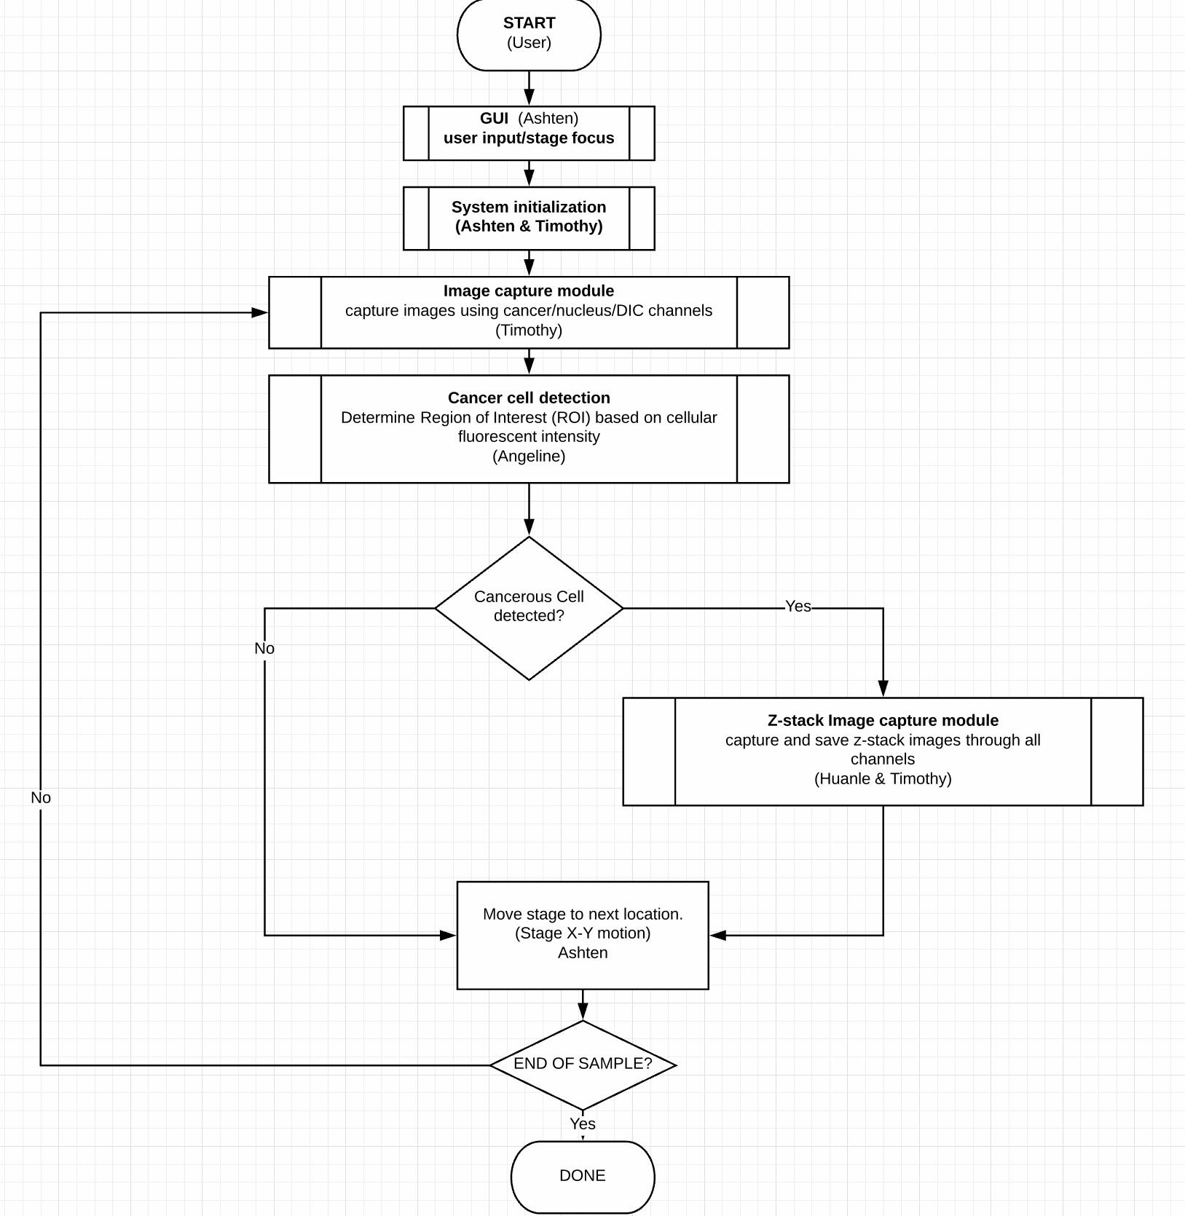

# Workflow

* 1. **TEAM MEMBER DELIVERABLE ASSIGNMENTS**

|  |  |  |  |
| --- | --- | --- | --- |
|  | **Workflow deliverables** | **Owner** | **Status** |
| 1 | Icy Script - User Interface | Ashten | In progress |
| 2 | Icy Script - Image Processing | Angeline | In progress |
| 3 | Icy Script - Image Capturing | Timothy & Huanle | In progress |
| 4 | Icy Script - Z-Stack incrementing & Reposition | Timothy | In progress |

* 1. **GANTT CHART**

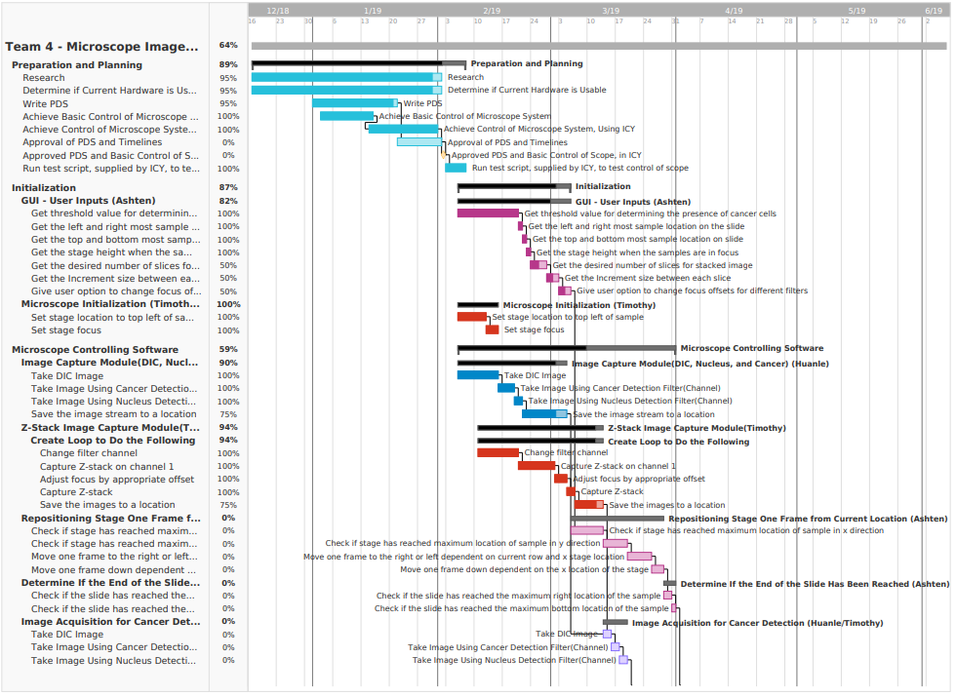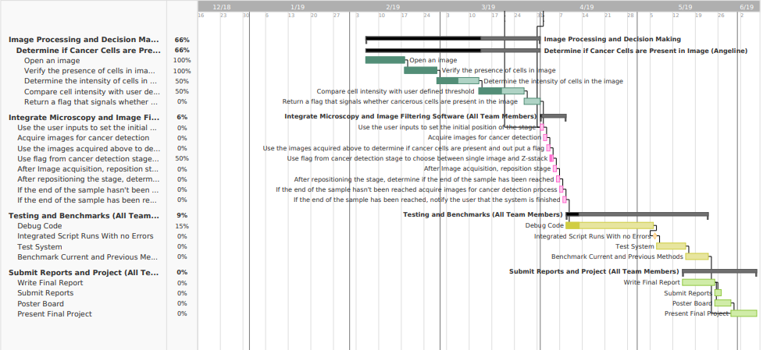

*Entirety of the Gantt chart is not shown. To view the live Gantt chart press the hyperlink provided in the README file under the “Project Status & Records” section on GitHub.*

# Design Specifications Approval

The undersigned sponsors acknowledge they have reviewed the **Design Specifications Document** and, by signing, agree that it accurately represents what they want the development team to produce. Any changes to the requirements in this document will be coordinated with and approved by the undersigned representative(s) of CytoImage DX and the development team.

|  |  |  |  |
| --- | --- | --- | --- |
| Signature: |  | Date: |  |
| Print Name: |  |  |  |
| Title: |  |  |  |
| Role: |  |  |  |

|  |  |  |  |
| --- | --- | --- | --- |
| Signature: |  | Date: |  |
| Print Name: |  |  |  |
| Title: |  |  |  |
| Role: |  |  |  |